It looks like Spring might actually be on the way. I hope you’ve all had a safe and healthy winter. I am excited for the season to be underway because we have been very busy over the winter. This newsletter will highlight some of the activities and, as always, the ELA Board welcomes your comments and feedback. Many of you contacted me over the winter asking about the lake levels and why they didn’t recede this year. The Department of Transportation (DOT) manages the spillway for the Canal Corporation and the New York Power Authority. The DOT was contacted numerous times in the Fall and Winter and their response was that all valves were open and the reason the water level had not receded was due to a very wet Fall. The DOT said they made numerous trips to the spillway and can also monitor water levels electronically. They compared this year to last year when there was also little to no drawdown in the lake level. Unfortunately, we, as an association, have no control over what goes on with the spillway. We can ask them questions, make requests, share observations, but ultimately, it’s in the DOT’s hands.
From Rosalyn Bandy:
Eatonbrook Lake Association Newsletter Spring 2019
  - President: Rosalyn Bandy. VP: Colleen McSweeney.
  - Secretary: Paula Sievers. Treasurer: Amy Coulter.
  - Trustees: Mike Gleason, Donna Isbell, Ben Rogge, Sarah Roy.
  - Past President: Andy Sapoznikov.

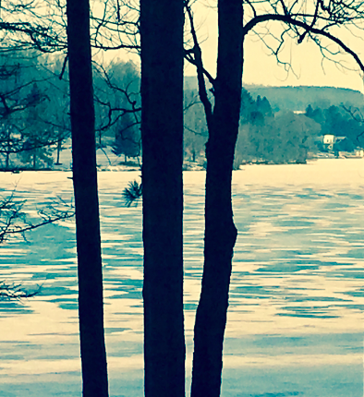
Photos courtesy of David Bowers
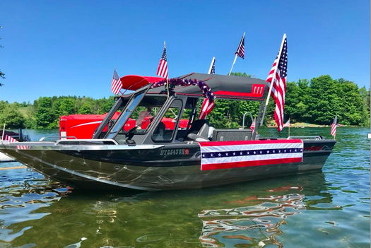
Photo courtesy of Pete Lilley

Annual Donation Letter
In the next couple of weeks, ELA secretary, Paula Sievers, will be sending out the annual request for donations for both the general fund and the fish fund. Thank you in advance for your support of the ELA. We have a wonderful community of people who care so much about our lake!
Photo courtesy of Roz Bandy

NYS DEC Grant

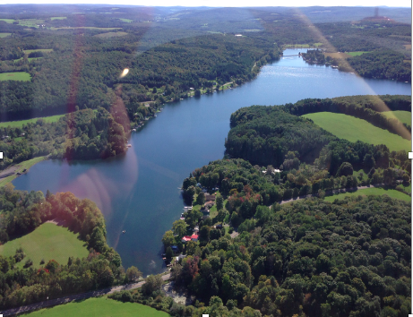
In February, I submitted an application for a state-wide competitive grant offered by the NYS Department of Environmental Conservation (DEC) to write a Lake Management Plan (LMP) with a focus on aquatic invasive species (AIS). The total amount of grant money requested was $11,200 over a three-year period to cover studies and research. We also owe big thanks to both the Towns of Nelson and Eaton Supervisors who wrote endorsement letters for the application and passed Town resolutions in support of the ELA application. We should know if we won the grant by our first ELA meeting.

By-laws
The Board of Directors is completing a review of the ELA by-laws. We want to make sure that all previous changes have been officially incorporated and we are reviewing for any additional changes that should be made. It’s appropriate to review by-laws every few years since the needs of the ELA evolve over time. We will present suggested updates at our first membership meeting.
Photos courtesy of Amy Rogge
Photo courtesy of Amy Rogge
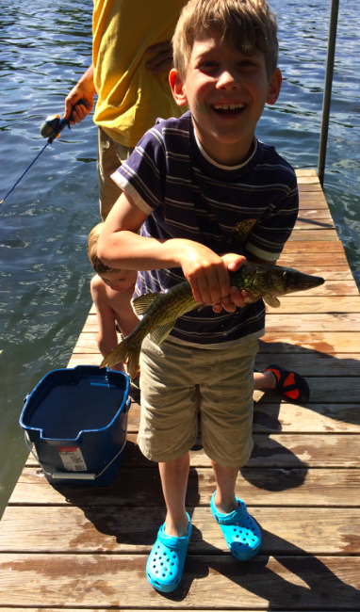  Photo courtesy of Cyndy Smith |  | Fish Stocking  Each year, many ELA members contribute to the Lake Fish Fund. The fund is used to stock predatory fish (walleye, bass). The primary reason for stocking predatory fish is to reduce the amount of panfish in the lake. The panfish eat the aquatic insects that prey on the Eurasian milfoil, an invasive species of plant in the lake. You can read more about ways to mitigate milfoil in Diet for A Small Lake, a book that our own Jim Cunningham coauthored. An excerpt is available here.  ELA Website  I am in the process of developing a website for the ELA. It will be used to communicate ongoing information about the lake that can be easily referenced, as well as a place to post events, studies, newsletters, and other items TBD that we deem appropriate. It will be in addition to our Facebook page. We have the option of keeping it a private website, only for those who subscribe to it, or we can make it a public website. This will be a topic of discussion at our first meeting in 2019. If you have some favorite photos of the lake that you would like to share for the website image library, or for newsletters, please send to rosalyn.bandy@hotmail.com

Jim Cunningham, our friend and neighbor, is the Director of the Madison County Federation of Lakes (MCFOLA). He wrote the following piece on the importance of lake associations.
The significance of Lake Associations: New York State has been a national leader among lake management organizations. Its no wonder considering NYS has slightly over 7000 lakes and ponds to protect. The New York State Department of Environmental Conservation (NYSDEC) in conjunction with the New York State Federation of Lake Associations (NYSFOLA) initiated the largest lake testing program nationwide using local lake association volunteers, called Citizen Statewide Lake Assessment Program (CSLAP). Hundreds of New York Lake Associations are involved in the program with over 400 trained volunteers sampling their lakes biweekly throughout the summer months. Samples are tested and shipped to state ELAP certified laboratories for analysis. The data is complied by both NYSFOLA and the NYSDEC. lakes are sampled and tested for a number of chemical and biological parameters which are evaluated for water quality trends for information on the lakes condition. These scientific evaluations may result in recommendations for lake associations managers. Not only are lake water quality conditions determined, but the NYSDEC sets water quality classifications based on these results. A poor classification, such as an impaired water body may help with funding, or grants to improve a lake condition. You can find your lakes results at the NYSFOLA web site which allows you to see changes and trends in water quality.
National Association: North American Lake Management Society (NALMS) NALMS provides a national forum which many of the state lake organizations attend the annual meeting. NYSFOLA attends and presents at the NALMS meetings each year. Understanding the nationwide trends in water quality especially invasive species presents and movement have been extremely beneficial to local lake managers.
State Association: New York State Federation of Lake Associations (NYSFOLA). NYSFOLA holds and annual conference in May each year. This years conference is in Lake George (May 3&4^{th)}. NYSFOLA is funded by NYSDEC to administers the CSLAP program for lake testing. NYSOLA has published a book called “Diet for small lakes” and a quarterly news letters called Waterworks. Jim Cunningham is a NYSFOLA past President and currently a board of director representing Eatonbrook Lake Association, and the Madison County Federation of Lake Associations. Jim also in a co-author of “Diet for Small Lakes”.
County Association: Madison County Federation of Lake Associations (MCFOLA). MCFOLA was formed to help bring together the many Madison County Lake Associations, Madison County Planning Department, Madison County Soil and Water Conservation District, NYSDEC region 7, and the Madison County Health Department. A MCFOLA meeting was held last fall in the Cazenovia that was well attended and fostered conversations between lake associations and Madison County departments. Scott Ingmire, director of the Madison County Planning Department spoke about the County aquatic weed harvester program and how to have your lakes weeds harvested. Jim Cunningham Eaton brook Lake Association is the President of MCFOLA. MCFOLA and the Cortland Onondaga Federation of Kettle Lakes Associations will hold an all day lake conference on August 16, 2019 at the Welch Allen Conference center in Skaneateles NY.
Local Lake Associations: There are hundreds of local Lake Associations within New York State. If you attend the annual spring NYSFOLA meeting you would be able to meet many of the people that make up the NYS local associations. Lakes within NYS have many different issues using different lake management methods and finding ways to involve their membership. Eatonbook Lake Association has been represented for over a decade at all of NYSFOLA meetings. Eatonbrook Lake Association was founded by the late Jim Justice. Meetings are held twice per year at the Erieville Firehouse conference room. Mike and Deb Gleason attended NYSFOLA CSLAP training and currently provide biweekly sampling for Eatonbrook lake. Rosalyn Bandy is the current Eatonbrook Lake Associations President. Rosalyn is currently working on many strategies to help the Eatonbrook Lake Association with communications and lake management. Please attend the spring meeting so you can be part of the many efforts to improve our lake and become a significant lake association member.
Respectfully, Jim Cunningham

First ELA Meeting of 2019
Mark your calendar for Saturday June 1 from 9-10:30 am at the Erieville Firehouse. In addition to regular ELA business, we will have an update from Jim Cunningham on New York Power Authority’s dam rebuild at DeRuyter Lake and what plans NYPA has for other dams in Madison County. If you have a particular topic that you would like added to the agenda for discussion, please email rosalyn.bandy@hotmail.com by May 1.
*** Summer will be here before you know it ***

